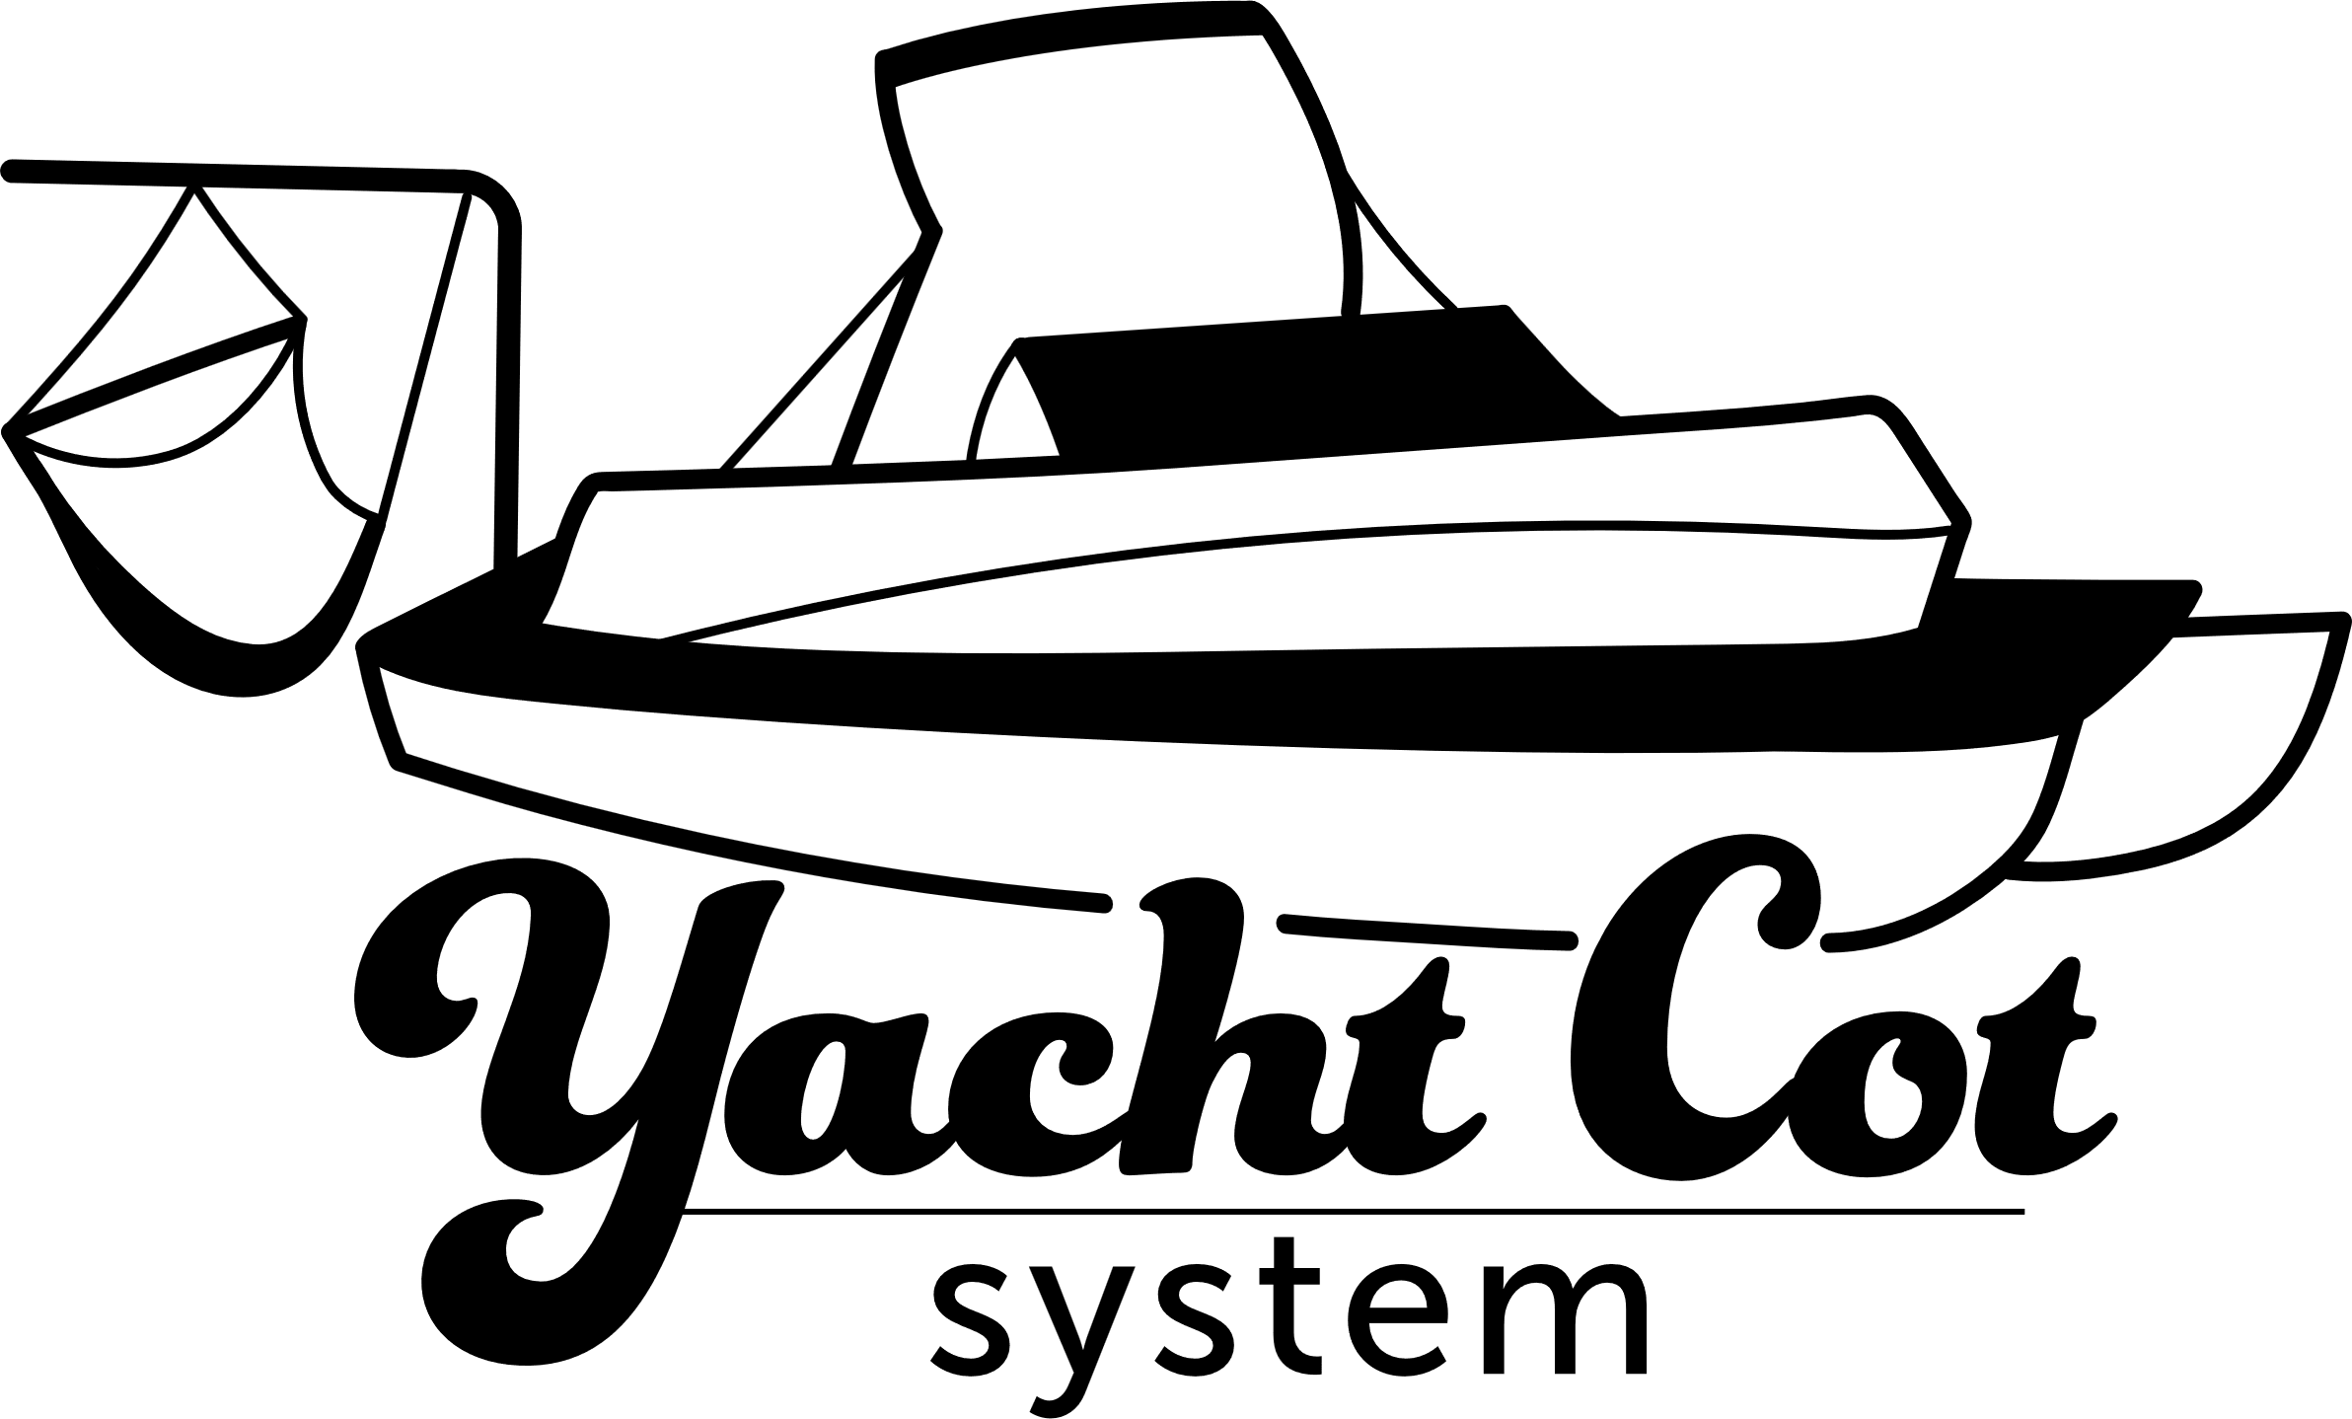

Product Liability Waiver
  - Assumption of Risk and Release of Liability
This Product Liability Waiver ("Waiver") is made and entered into by the purchaser ("Purchaser") of the product ("Product") provided by the ROW Systems LLC ("Seller").

Assumption of Risk
By purchasing and/or using the Product, the Purchaser acknowledges and understands that the use of the Product involves certain inherent risks. The Purchaser voluntarily assumes all risks associated with the use, handling, and operation of the Product, including but not limited to the risk of injury, damage, or loss. This product is designed for use in high-risk environments (it holds a user over the water) and may expose users to hazards including but not limited to: drowning, collision, falls, equipment failure, and serious injury.

Release of Liability
To the fullest extent permitted by law, the Purchaser agrees to release, waive, and discharge the ROW Systems LLC, its owners, employees, and agents from any and all liability, claims, demands, actions, or causes of action arising out of or related to any loss, damage, or injury, including death, that may be sustained as a result of the use or misuse of the Product.

Purchaser's Responsibility
The Purchaser agrees that they are solely responsible for the proper use, maintenance, and storage of the Product. The Purchaser affirms that they have read and understood all instructions, warnings, and guidelines provided with the Product and will follow them at all times.

Indemnification
The Purchaser agrees to indemnify and hold harmless the Seller from any claims, damages, or expenses (including attorney fees) arising from the Purchaser's use or misuse of the Product.

Severability
If any provision of this Waiver is found to be invalid or unenforceable, the remaining provisions shall remain in full force and effect.

Acceptance of Terms
By purchasing and/or using the Product, the Purchaser acknowledges that they have read, understood, and agreed to the terms of this Product Liability Waiver.
Purchaser Name: ____________________________
Signature: _________________________________
Date: ____/____/________

Product Install Waiver
  - Assumption of Risk and Release of Liability
This Product Liability Waiver ("Waiver") is made and entered into by the purchaser ("Purchaser") of the product ("Product") provided by ROW Systems LLC ("Seller").

Assumption of Risk
By purchasing and/or using the Product, the Purchaser acknowledges and understands that the install of this product will require permanent modifications to your watercraft:
- 1 x 2.5 inch hole cut in the decking (Posts)
- 6 x ½ inch holes drilled int the decking of the watercraft (Bolts)
- 6-8 x 3/8 inch holes in the outer frame of the watercraft (Frame Bolts)
Once these modifications are made they are permanent and the responsibility of the owner.

Release of Liability
To the fullest extent permitted by law, the Purchaser agrees to release, waive, and discharge the Seller, its owners, employees, and agents from any and all liability, claims, demands, actions, or causes of action arising out of or related to any loss or damage from the modifications required to install the Yacht Cot System.

Acceptance of Terms
By purchasing and/or using the Product, the Purchaser acknowledges that they have read, understood, and agreed to the terms of this Product Liability Waiver.
Purchaser Name: ____________________________
Signature: _________________________________
Date: ____/____/________

